|  |  |  |
| --- | --- | --- |
|  | **Lab 2 Pre-lab**  **Due Date : 14/10/2019, 12:30**  **Name :**  **No :**  **Group : (e.g. Monday 13:00, 6)**  **Subject: Thevenin Equivalent and Maximum Power Transfer** |  |

Pre-lab Procedure:

* Each student must prepare and upload the pre-lab INDIVIDUALLY!
* Upload as a .PDF file.

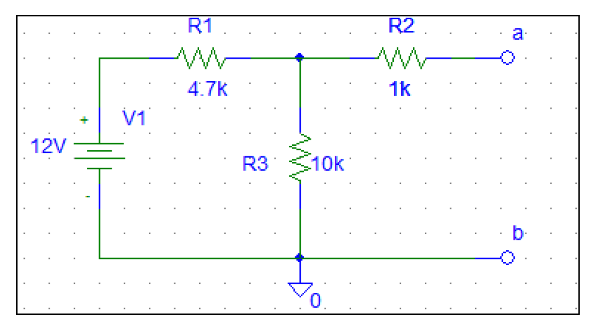

**Figure 1**

1. Which colors represent the resistors used in the circuit? (ex. Violet, Yellow, Brown) Ignore the tolerances for now.
   1. 4.7KΩ : _____, _____, _____
   2. 1KΩ : _____, _____, _____
   3. 10KΩ : _____, _____, _____
2. Draw the schematic for the circuit in Figure 1 using LTSpice and simulate it.

Also, remember to label the points a and b. Save your schematic. Run a DC operation analysis and note the open circuit voltage across a and b (You should determine the node that corresponds to a-b in the circuit). Voc = ______V.

1. Now, connect the points a and b with a wire. Note that now R2 has some current flowing through it and it’s the same current flowing through a-b, so Iab=Isc=I2=______mA.
2. We have everything we need to calculate the Thevenin Resistance of the circuit because RTh=Voc/Isc=______/_____m=_______KΩ

(Interesting: if we wanted to find the equivalent resistance in the circuit, we have R1||R3+R2 = [R1R3/(R1+R3)]+R2 =_____ KΩ).

1. Replace the wire between a and b with a 1KΩ resistor and name it Rload. Run a DC operation analysis. Use this result to fill in the table below up to 3 decimal digits (ex. 1.227). You should change the resistor value to fill values for each row. Note that Iab = Iload and Vab corresponds to the node at the top of Rload. Then use your calculator to find the power at Rload by multiplying Iab and Vab and fill in the table values.

|  |  |  |  |
| --- | --- | --- | --- |
| Load | Iab (mA) | Vab (V) | Pab=IabxVab (mW) |
| 1KΩ |  |  |  |
| 2KΩ |  |  |  |
| 3KΩ |  |  |  |
| 4KΩ |  |  |  |
| 5KΩ |  |  |  |
| 6KΩ |  |  |  |
| 7KΩ |  |  |  |
| 8KΩ |  |  |  |
| 9KΩ |  |  |  |
| 10KΩ |  |  |  |

1. Draw current, voltage and power values for each step of Rload. You can use MS Excel or MATLAB/Octave but you must include the graph in this document. When is the power maximum?

>>>INSERT GRAPH HERE<<<

1. Convert this document to .PDF and upload. Thank you!